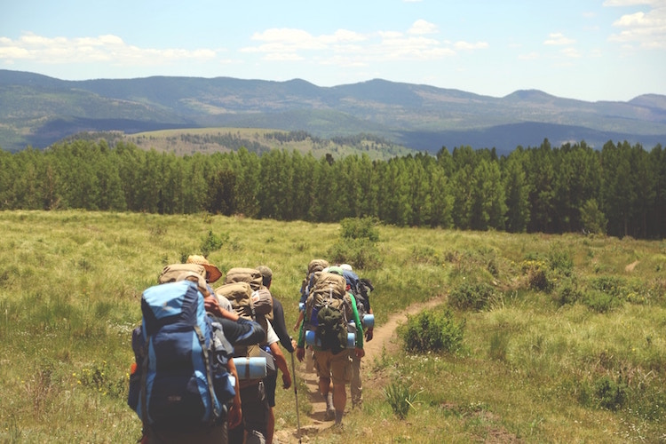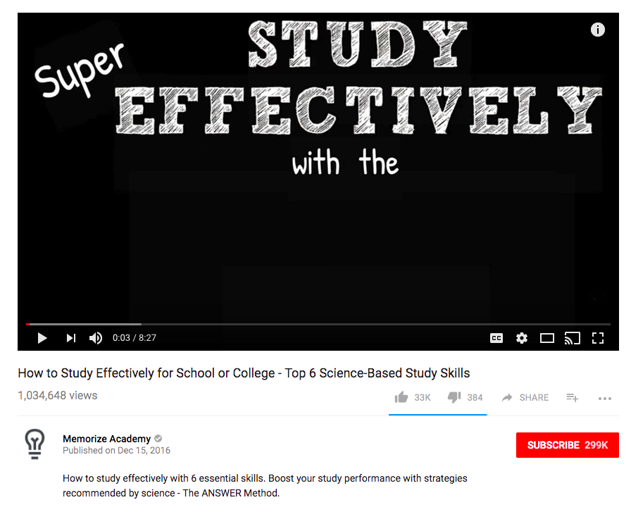

Author’s real name

**with Samantha Dorfman**

**Get Ready to Hike**

A great hike might be the most fun you’ve ever had—if you’re prepared. Samantha Dorfman will get you ready to hike so that you’ll have everything you need for a fun time on the trails.

H

hikingisliving

Published on February 10, 2011

772,251 views

Get Ready to Hike

12345

0:05 / 13:35